Section B

**Table of Contents**

Section B 1

Slide 1: Plan for successful strategic change 3

Slide 2: Introduction to the organization 4

Slide 3: Organizational change context 5

Slide 4: Change management timeline 6

Slide 5: Insights on change requirements 7

Slide 6: Approach to enabling successful change 8

Slide 7: Chosen change management strategy 9

Slide 8: Roadmap towards the change 10

Slide 9: Plan for supporting employees 10

Slide 10: Leadership’s role in change 11

Slide 11: Mechanisms for monitoring change 12

Slide 12: Measuring change objectives 12

Slide 13: Overcoming resistance to change 13

Slide 14: Risks and contingency planning 14

Slide 15: Supporting evidence for the strategy 14

Slide 16: Strategic steps justification 15

Slide 17: Clear responsibilities 16

Slide 18: Conclusion 17

Slide 19: Q&A slide 17

References 19

**Slide 1: Plan for successful strategic change**

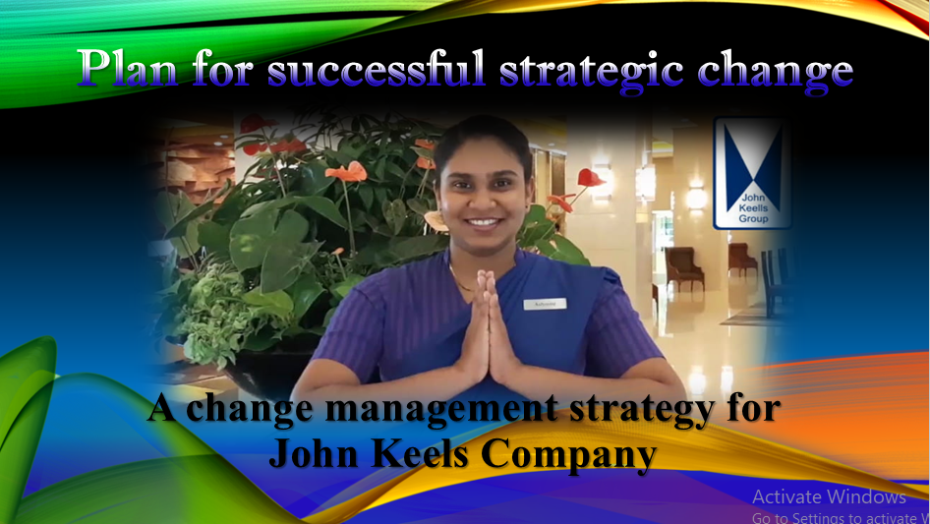

Good morning/afternoon to all of you. Presenting to you this presentation about the plan for successful strategic change at John Keels Holdings. The tour is devoted to announcing a complete plan that explains how the organization is going to manage and implement the change planned for it. The plan targets innovations in improved efficiencies and sustainability of growth. It covers all the moments that will capture such key aspects as change context, roadmap, employee support, leadership roles, and systems of monitoring. So, let us set the stage for this discussion.

**Slide 2: Introduction to the organization**

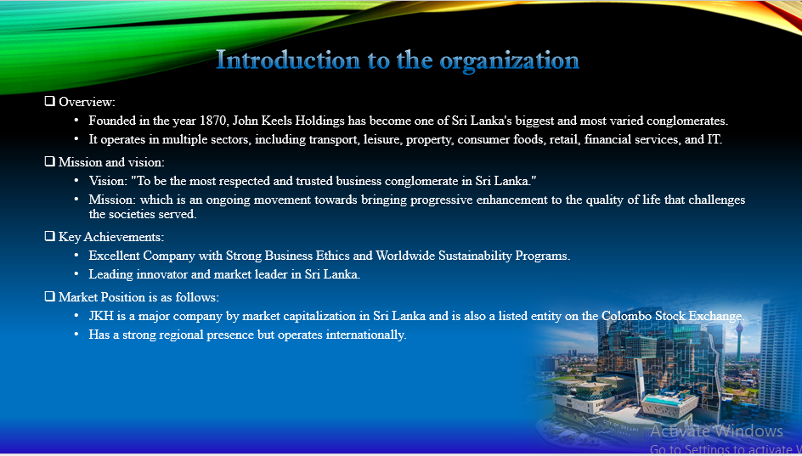

John Keels Holdings or JKH is not only the largest but also the most diversified conglomerate in Sri Lanka engaging in retail, leisure, transportation, property, and IT. JKH has been a carrier in progressive terms with its approach to financing innovative solutions and sustainability initiatives for the environment. The company 'Empower and Enrich Lives' has been successively guiding each of the strategic decisions made within the organization. This initiative would move in tandem with JKH's philosophy toward innovation in its customer-centric solutions long on value creation. (PLC, 2024)

**Slide 3: Organizational change context**

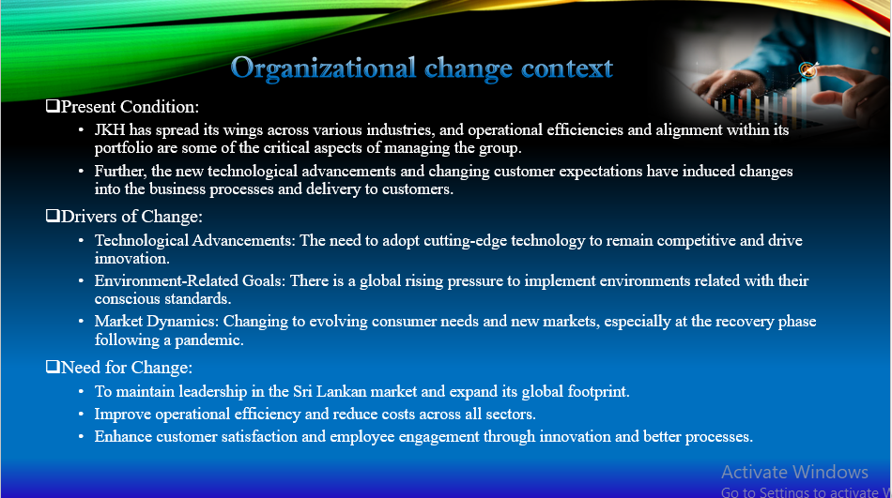

The call for organizational change at JKH encounters the fast revolving forces of the market in the form of greater competition and advancing technology. To keep itself at the top as a leader, JKH should strengthen its operational efficiency- go into the process of renovating itself into digital transformation and modifying organizational behaviours to satisfy developing customer expectations. Government trends of sustainability and compliance in ESG demand intervention. It is by this inertia of change: positioning JKH for growth for many tomorrows through different innovative solutions as well as developing a culture of agility and resilience in the organization. (Keels, 2023)

**Slide 4: Change management timeline**

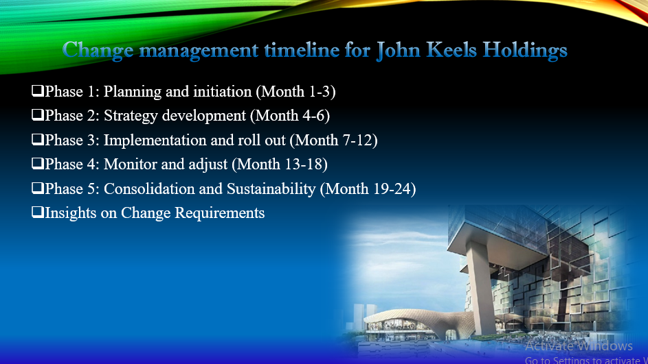

This is the timeline for change management at John Keels Holdings. It starts with a three-month preparatory phase, touching on stakeholder engagements and risk analysis. After that, there's six months of implementation on digital transformation, training, and systems enhancements. The subsequent three months will see monitoring and adjustment against objectives. The last six months will evaluate and engraft the outcomes into the culture of the organization to truly enjoy benefits from these changes. (Keels, 2023)

**Slide 5: Insights on change requirements**

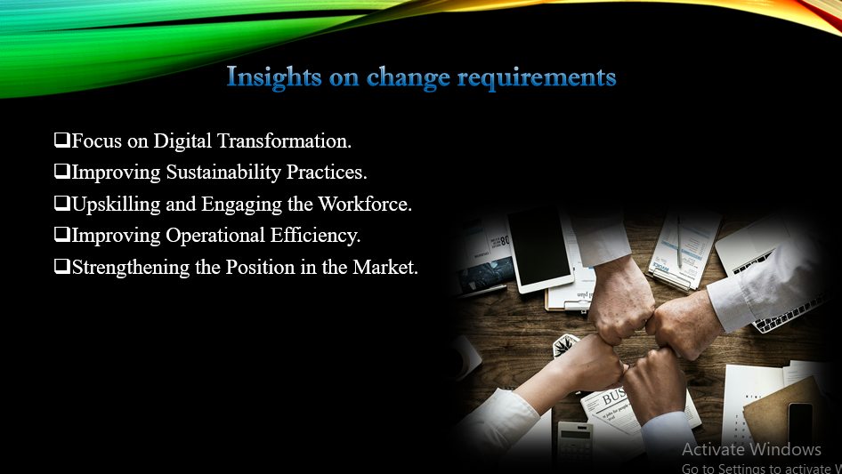

For a worthwhile strategy for competitive advantage, John Keels Holdings introduce engaging change drivers to the organization. Advanced digital technology deployment, operational efficiencies, customer experience enhancement, etc., will also enforce compliance to sustainability and ESG standards that are fast becoming non-negotiable by stakeholders. Most importantly, a culture shift for innovation and agility in the workplace is also needed. These insights make change strategy necessary in structuring one's alignment with market demand and long-term company vision. (PLC, 2024)

**Slide 6: Approach to enabling successful change**

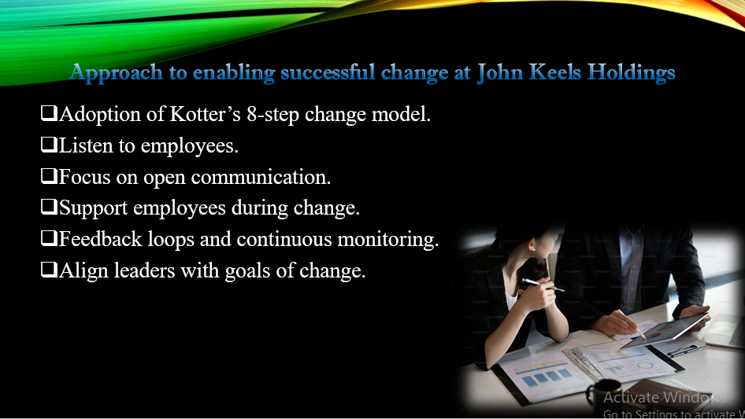

John Keels Holdings will adopt a phased approach by starting with clear and precise communication and engagement with stakeholders in enabling effective change. This will be followed by alignment with leadership, equipping employees with skills, and introducing technology to make transitions easier. Continuous feedback will be sought to address issues immediately. Progressive change is, therefore, not just a matter of implementation, but involves embracing change pensively across all levels and thus creating a culture of flexibility and innovation. (Ravindu, 2020)

**Slide 7: Chosen change management strategy**

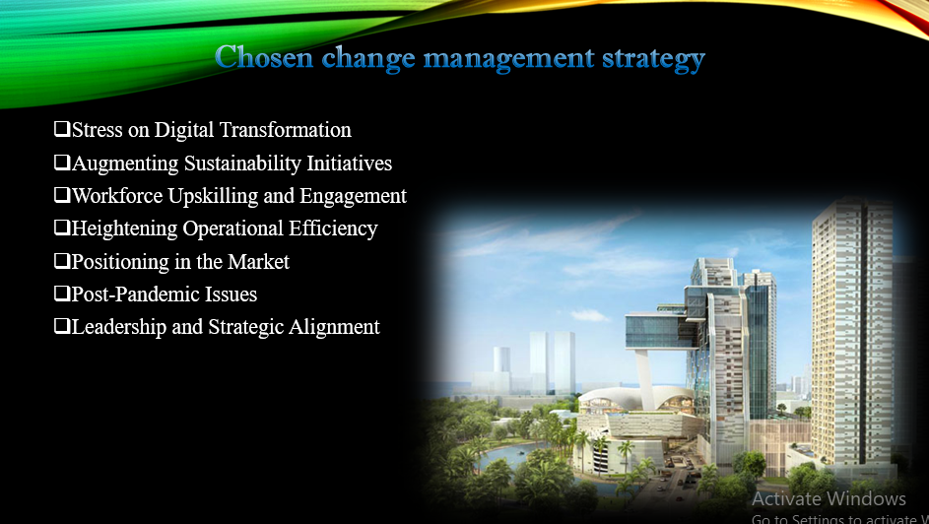

The elite and elegant corporate change management strategies for John Keels Holdings embrace transformational and incremental changes in all aspects of the program. Additionally, the leadership should be empowered across the organization, whereby clear vision communication and clear stakeholder involvement will be facilitated. Training and development interventions will support the employees' transition, while progress assessments will be regularly conducted to ensure that it aligns with established goals. This balance of innovation within the organization will help carry out a smooth transformation about reinforcing the company's position within the market and its internal culture. (Aiswarya, 2021)

**Slide 8: Roadmap towards the change**

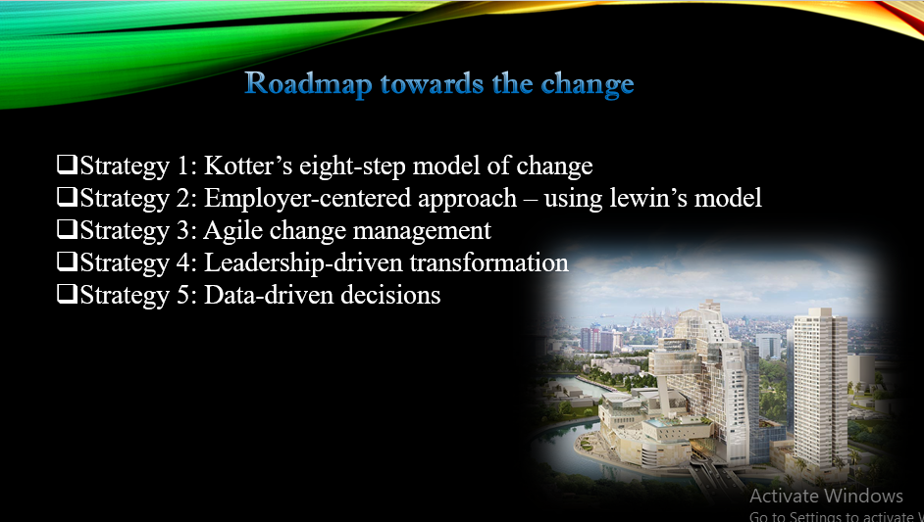

This is the roadmap that signifies the approach phased out on change at John Keels Holdings. It kicks off with preparation with a primary focus on the commitment of stakeholders and review of existing systems. Implementation phase-all new technologies and training rollout. Consolidation phase-expanding the changes across the organization keeping close tabs on progress. Then, finally, the internalization and evaluation of changes will be formulated by which sustainability and focusing on long-term strategic goals to last an impact for holding would be initiated. (Project, 2024)

**Slide 9: Plan for supporting employees**

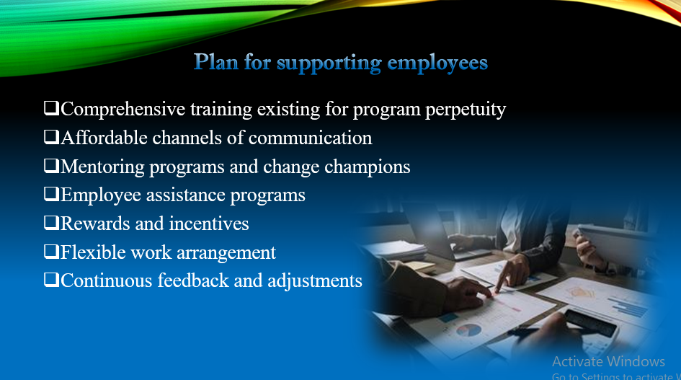

Supporting employees throughout the change process is crucial for success. At John Keels Holdings, we will offer continuous training and skill development programs to ensure that employees are equipped with the tools needed to adapt. Regular communication will keep them informed, while feedback channels will allow us to address concerns promptly. Additionally, we will foster a supportive environment through leadership involvement, ensuring that employees feel empowered and confident in embracing the changes. (Keels, 2024)

**Slide 10: Leadership’s role in change**

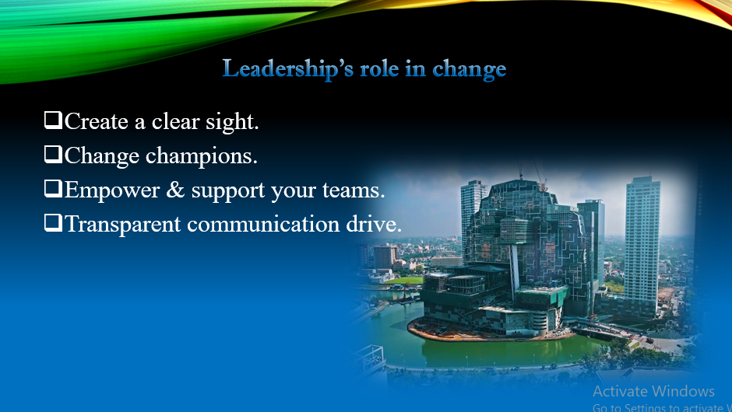

Leadership at John Keels Holdings is set to play an important role in the change process. They should present a compelling vision or picture of the end result that will instil confidence and lead the charge. This will rally employees to ensure that there is a buy-in from all levels on the part of management by modelling active support and facilitating the development of an open culture. Beyond that, leadership will also entail following up progress, problems that crop up, and reviewing action plans as necessary. Their commitment and involvement will most likely spell the difference between the success and long-term viability of the change process. (Keels, 2024)

**Slide 11: Mechanisms for monitoring change**

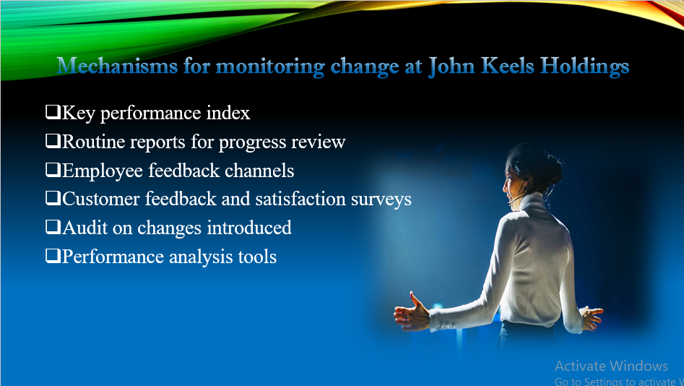

Performance tracking tools, regular reviews of progress, and employee feedback mechanisms are some of the avenues through which John Keels Holdings will keep track of change within the organization. Assessment of the performance of each change will be done and challenges identified to help the organization remain focused on the end goals of putting through the specified changes. (Keels, 2024)

**Slide 12: Measuring change objectives**

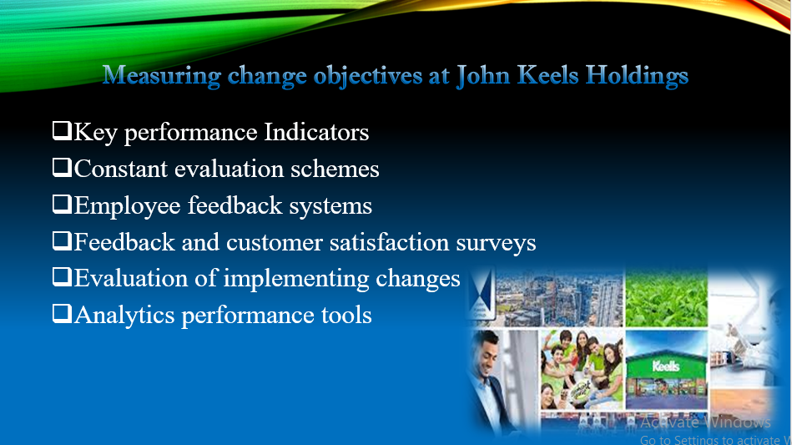

In measuring changes in objectives with regard to the work performed at John Keels Holdings, obviously it has to define measurable targets, well in alignment with the strategic vision of the company. The performance indicators, such as an improvement in productivity and customer satisfaction along with more financial viability, are going to be put under constant observation and measurement in order to determine whether the desired result is achieved at the end of the day. (PLC, 2023)

**Slide 13: Overcoming resistance to change**

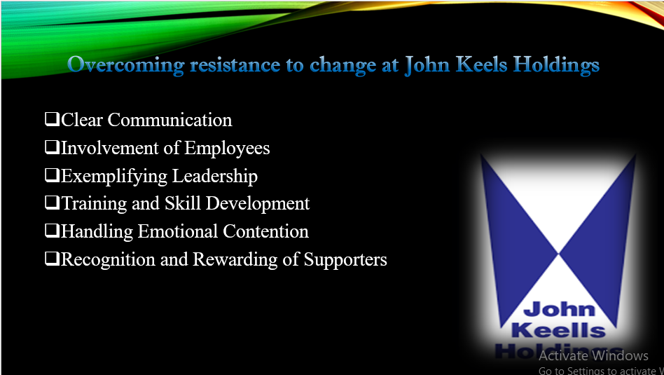

Change management at John Keels Holdings would entail clearly communicating, followed by active listening and involving employees in the process of change. This would help create a more enlightened environment for change in smooth transition and adoption by addressing issues concerning the concern, support provision, and benefits from change that could reduce the resistance. (Amanda, 2016)

**Slide 14: Risks and contingency planning**

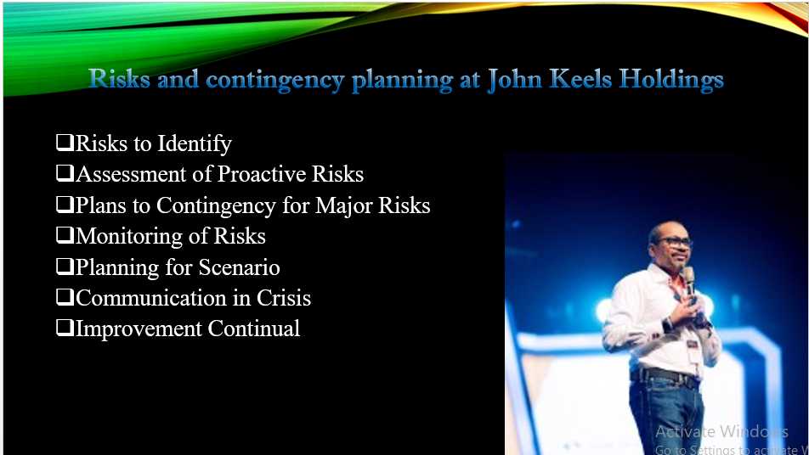

The risk associated with the change process at John Keels Holdings will be possible disruptions, resistance, and resource shortages. We will provide contingency plans, alternative strategies, resource allocations, and proactive communication to mitigate these risks. Continuous risk monitoring enables adapting and dealing with unforeseen occurrences in an optimal and effective manner. (Keels, 2024)

**Slide 15: Supporting evidence for the strategy**

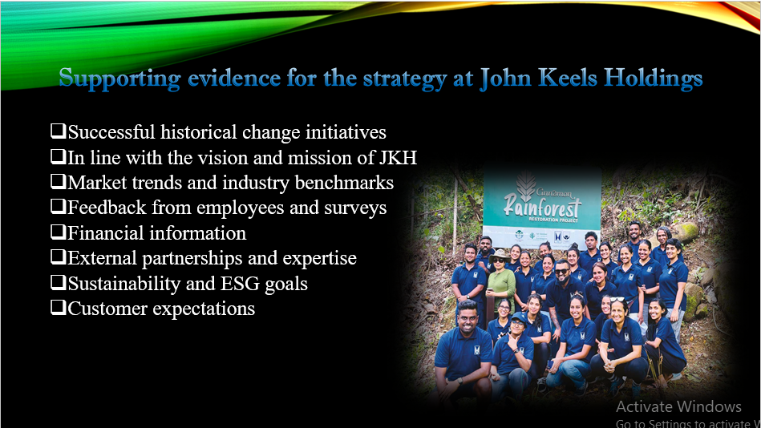

Such evidence for supporting our change strategy will be in the form of the industry best practices and case studies from other similar organizations and will also come in the form of the data from internal assessments. All these sources validate our strategy and show that the proposed strategy is proved in the method as an evidence-based approach to achieve sustainable change, improve the organizational performance, and foster long-term growth. (Ltd, 2024)

**Slide 16: Strategic steps justification**

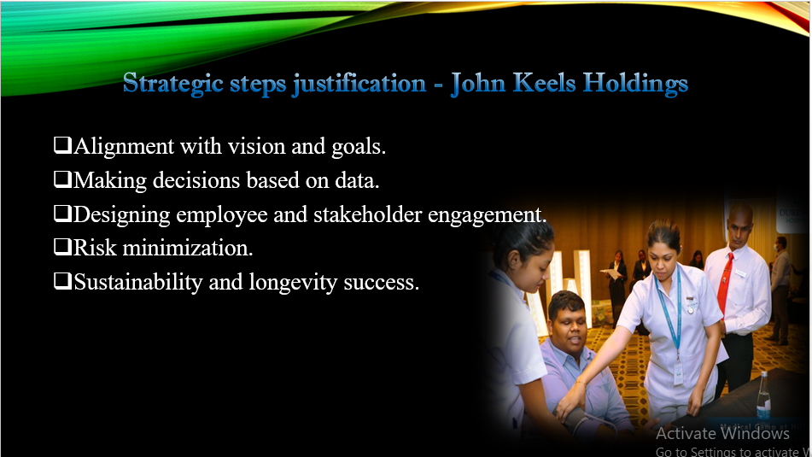

These aforementioned strategic steps advocated by John Keels Holdings are justified as they are aligned with the company's vision multi-faceted approaches in innovation and growth. The most strategic decision to take is minimizing disruption through data-driven decisions, employee engagement, and phased implementation. The approach taken by the company is sustainability-centered, risk-averse, and lasting change in the company's culture. (Ltd, 2024)

**Slide 17: Clear responsibilities**

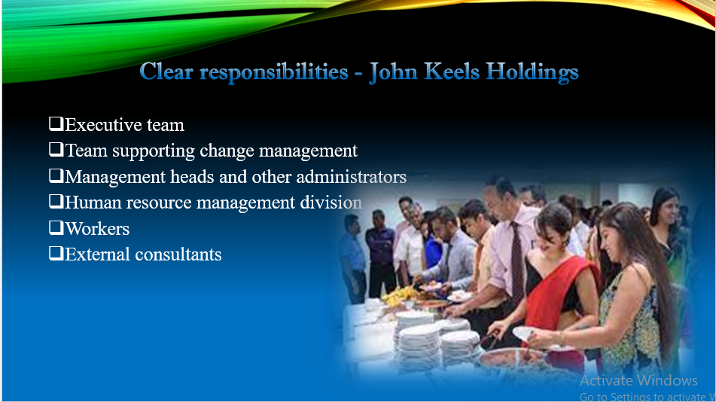

Clear-cut responsibilities at John Keels Holdings ensure that effective change management is in place. Leadership sets the vision and pursues actions, while the change management team advises and implements the strategy. Department heads and HR take care of employee training and address the grievances regarding efficacy. They ensure that these are closely aligned with the overall change. Massive employee involvement guarantees effectiveness in transfer and adopting such change. (Keels, 2024)

**Slide 18: Conclusion**

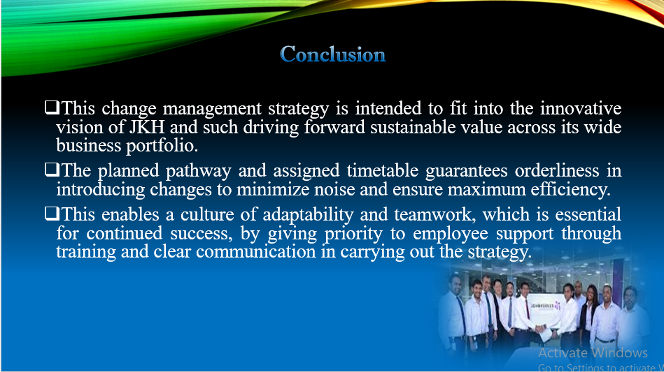

Thus, the strategic change plan is designed to drive John's Keels Holdings into an environment where they are developing a culture of strategic growth and innovation. Aligning the leadership-clear responsibilities and continuous support for employees ensure a smooth transition. Monitoring and measuring progress, along with proactive risk management, will ensure that the company is agile and successful to achieve its long-term objectives. (Keels, 2024)

**Slide 19: Q&A slide**

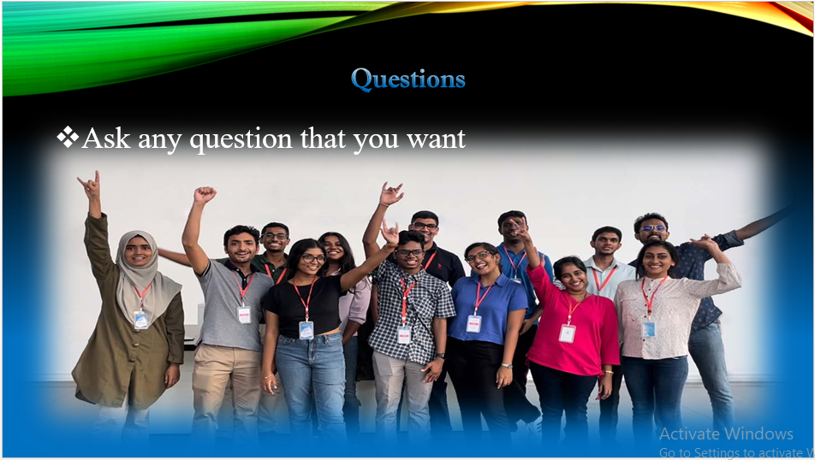

Now I am open to accept any query or clarification on the topic being presented. Feel free to ask anything or even express more personal concerns associated with the changes in the change management strategy. I will try to answer every query to my best ability and provide additional insights if there would be any required.

# **References**

Aiswarya, 2021. *Change Leadership.* [Online]   
Available at: <https://www.scribd.com/document/501494089/BSP-6064>

Amanda, 2016. *Managing Human Capital at John Keells Group.* [Online]   
Available at: <https://www.slideshare.net/slideshow/assignmentmhc/65980332>

Keels, J., 2023. *CORPORATE GOVERNANCE COMMENTARY.* [Online]   
Available at: <https://keells.com/resource/governance/John-Keells-Holdings-PLC-AR-2021_22-Corporate-Governance.pdf>

Keels, J., 2023. *Overview of the John Keells Group and review of FY2023 performance.*[Online  
Available at: <https://keells.com/resource/reports/investor-presentations/annual-investor-presentation-2022-23.pdf>

Keels, J., 2024. *CORPORATE GOVERNANCE COMMENTARY.* [Online]   
Available at: <https://www.keells.com/resource/reports/governance/John-Keells-Holdings-PLC-AR-2022_23-Corporate-Governance.pdf>

Keels, J., 2024. *Leadership.* [Online]   
Available at: <https://www.keells.com/leadership/>

Keels, J., 2024. *nticipating the future.* [Online]   
Available at: <http://www.johnkeellstea.com/html/John-Keells-2016.pdf>

Keels, J., 2024. *RISKS, OPPORTUNITIES AND INTERNAL CONTROLS.* [Online]   
Available at: <https://www.keells.com/resource/reports/governance/John-Keells-Holdings-PLC-AR-2022_23-Risk.pdf>

Keels, J., 2024. *VOLUNTEERISM.* [Online]   
Available at: <https://www.johnkeellsfoundation.com/volunteerism/>

Ltd, D. K. (., 2024. *Corporate Strategy.* [Online]   
Available at: <http://dspace.vnbrims.org:13000/xmlui/bitstream/handle/123456789/2486/3.%20CorporateStrategy-DHL%20Keells%20Pvt%20Ltd.pdf?sequence=1&isAllowed=y>

PLC, J. K., 2023. *Environmental, Social & Governance.* [Online]   
Available at: <https://www.keells.com/esg/>

PLC, J. K., 2024. *150 Years and Beyond:Growing with the Nation.* [Online]   
Available at: <https://www.keells.com/>

PLC, J. K., 2024. *Unlocking Networks of Value.* [Online]   
Available at: <https://www.johnkeellsgroup.lk/resource/reports/group-annual-reports/John-Keells-PLC-Annual-Report-23-24.pdf>

Project, N., 2024. *John Keells Modern Retail Infrastructure Expansion Project.* [Online]   
Available at: <https://www.adb.org/projects/55143-001/main>

Ravindu, 2020. *Critical Examination of HR Models and Analysis of Effective Leadership of John Keells Holdings PLC (JKH).* [Online]   
Available at: <https://www.researchgate.net/publication/341038067_Critical_Examination_of_HR_Models_and_Analysis_of_Effective_Leadership_of_John_Keells_Holdings_PLC_JKH>